Tekli

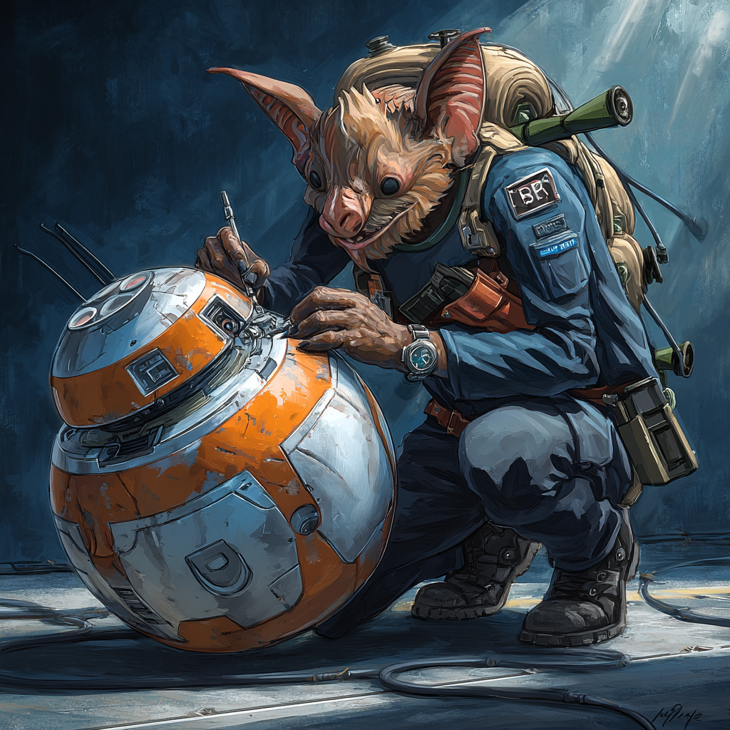
The YT-1300 spoke to him before he bought her. Not in words. Machines did not use words. They used harmonics and heat signatures and the way metal stressed under load. The ship sat in a junkyard on Ord Mantell, third row back, half-buried under salvage that was actually worthless.
Three previous owners had given up. The first lost her in a sabacc game. The second could not fix the hyperdrive motivator. The third died when the power core went critical during a botched modification. The yard owner wanted her gone. Bad luck, he said. Cursed, he said. Fifty credits for scrap value.
Tekli heard something else. Under the rust and carbon scoring, systems hummed with potential. The frame was twisted but not broken. The hyperdrive was not damaged, just misaligned by someone who did not understand Corellian engineering. The power core had gone critical because an idiot had bypassed safety protocols without adding redundancies.
He bought her with every credit he had saved. The yard owner laughed. Another Chadra-Fan who thought he was smarter than three failed mechanics. Tekli did not argue. He had work to do.
The first month was diagnosis. Crawling through every system. Learning her personality. She liked to run hot. Her port engine had more thrust than starboard. Her nav computer calculated jumps 0.3 seconds faster than standard. Small things. Important things.
The second month was surgery. Realigning the hyperdrive with modifications that bent regulations but not physics. Adding heat sinks where previous owners had just added prayers. Replacing safety protocols with better protocols that actually kept people alive while letting the ship perform beyond specifications.
The third month was optimization. Sensor baffles that confused inspection scans without triggering alarms. Engine modifications that turned wallowing into dancing when needed. Hidden compartments that existed in blind spots between standard scanning arrays. Every modification had three backups. Every backup had an override. Every override had a whispered apology to the ship for what he was asking her to do.
She flew like dream after that. Not a pretty dream. Not a smooth dream. But a dream that got you where you needed to go and brought you back alive.
The Empire noticed eventually. They always noticed when someone made something work better than their specifications allowed. The recall bulletin was comprehensive. Any vessel with undocumented hyperdrive modifications. Mandatory impound for safety inspection. They would strip her down. Find every beautiful violation. Turn her back into scrap.
Tekli was refueling at a border station when the message appeared in his nav computer. No transmission record. No data trail. Just text that deleted itself after reading: "Bulletin hash: IN-7739-MD. Inspection teams deployed to following routes." A list of coordinates followed. Then: "Avoid these vectors. Kestrel keeps good pilots flying."
He changed course immediately. Jumped to secondary routes. Stayed in systems the inspection teams had already swept. Three times he passed Imperial patrols by hours. Once by minutes. The YT-1300 stayed free. Tekli stayed free.
A week later, another message: "Clean flying. Your modifications show artistic understanding of engineering. I have cargo runs requiring such artistry. Standard rates plus fuel. Interested?"
Tekli was interested. The first job was medical supplies to a quarantine zone. The Empire had blockaded the system. Said the plague was too dangerous. Let it burn out naturally. Let the people burn out with it. Kestrel's route went through three Imperial checkpoints. The YT-1300's new transponder codes passed perfectly. The medicine reached people who needed it. Children lived who would have died.
The credits were good. The fuel was free. The feeling of flying past Imperial interdiction was better than both.
More jobs followed. Food to settlements the Empire was starving. Construction supplies to colonies rebuilding after Imperial "pacification." Always threading needles between patrols. Always dancing on the edge of disaster. The YT-1300 sang during those runs. Tekli sang with her.
After six months, Kestrel suggested crew additions. "Solo flying increases risk. Additional personnel provides redundancy. I can arrange introductions."
Bill arrived first. Young Zabrak. Quiet. Moved like he was dancing with gravity. Loaded cargo without question. Handled his share of port fees and provisions. Stayed up during night cycles practicing something in the cargo hold that looked like combat forms but might have been exercise. Tekli did not ask. Bill did not volunteer.
Kaa'Reth came next. Verpine slicer who made their documentation perfect. Every manifest. Every registration. Every port record. All clean. All boring. All exactly what Imperial inspectors wanted to see. The Verpine also improved the ship's systems. Subtle things. Better encryption. Faster processors. Comm arrays that could hide signals inside normal traffic.
They flew as a trio for months. Good work. Clean escapes. Growing reputation among people who needed things moved without Imperial notice. Then Kestrel suggested one more addition. "Security specialist. Barabel. Professional. Necessary for upcoming operations."
Ragath was everything advertised. Professional. Dangerous. Protective of crew. He took the forward cabin where he could reach the boarding ramp fastest. He checked weapons with the same care Tekli checked engines. He stood guard without being asked. The pirates who tried to board them learned why Barabel had a reputation.
The crew worked. They were not friends exactly. Something more professional. Something more reliable. They trusted each other with their lives daily. That mattered more than friendship.
Now Kestrel wanted precision flying for a courier intercept. Thread the needle past escort fighters. Get the team in. Get them out. Nobody else sees them coming or going. In exchange: factory-grade motivator parts and legal transponder refit. Real registration. Real documentation. No more running.
Tekli ran his hands over the YT-1300's controls. She was ready. He had made her ready. Every system tuned. Every backup checked. Every modification tested. She would fly through the eye of a needle if he asked. She would dance on solar winds if necessary. She would bring them home because that was what she did.
"Soon," he whispered to her. "Soon we fly the hardest path. Soon we show them what you can do."
The ship hummed. Maybe agreement. Maybe just standard mechanical resonance. Tekli chose to believe it was agreement. The alternative was admitting he talked to machines that could not hear him. That way led to questions about sanity he preferred not to answer.
The coordinates waited in the nav computer. The crew prepared their equipment. The escorts would be military grade. The window would be measured in seconds. The margin for error did not exist.
Tekli smiled. This was the kind of flying he was built for. The kind the YT-1300 was rebuilt for. The kind that separated pilots from artists.
He would paint the stars with his flying. The Empire would never see the brushstrokes.

